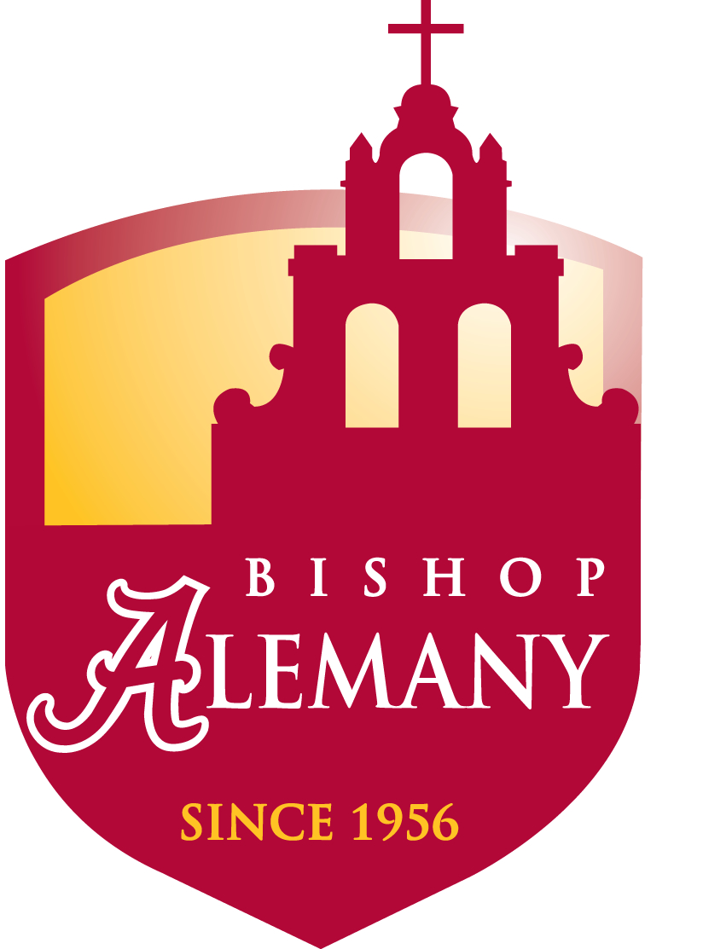
Bishop Alemany’s Parent Association
Family Communion Mass & Breakfast

We are inviting everyone to celebrate Mass in the Alemany Chapel.
A full Breakfast immediately following in the Alumni Hall
Cost $5 per person

During Mass we will pray for our Principal Frank Ferry and his recovery.
Breakfast donations & proceeds will be donated in
Frank Ferry’s honor to help
Alemany students who are in financial need.

Sunday, January 23, 2011
9:30am – Mass
A Full Breakfast immediately following

Food and/or monetary donations are much appreciated – please contact
Lisa Lewis at 818-402-2730 for a list of needed items or questions
---------------------------------------------------------------------------------------------------------------------------------------------------
Family name:__________________________________________________
Number attending:_____________________ Phone number:_____________
Total payment: $____________________ ($5 per person) checks payable to
“Bishop Alemany High School”
Include payment with this form and mail or drop off to:
Bishop Alemany High School c/o: Parent Association 11111 North Alemany Dr. Mission Hills, CA 91345

